**Shortcuts in R Studio**

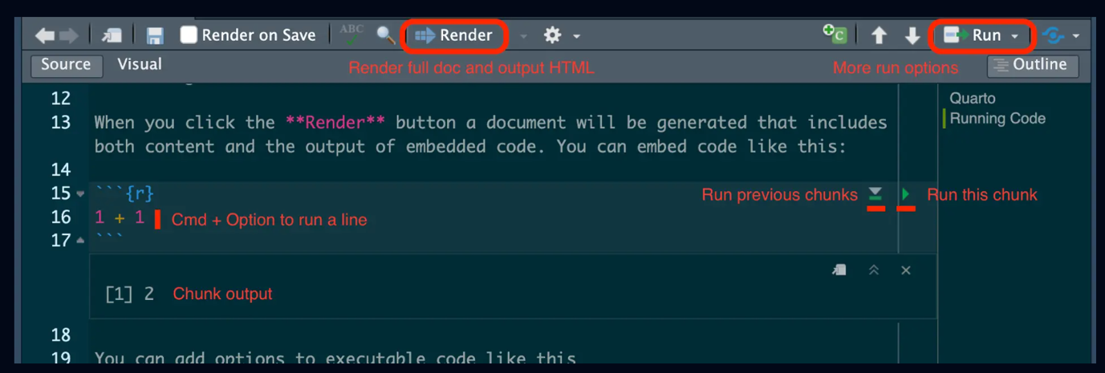

* **Run current chunk**: the little right green arrow at the right of the chunk runs the **current chunk only**.
* **Run all chunks above**: the little down grey arrow allows to run all the previous chunks.
* **Cmd + Enter**: this shortcut runs only 1 line of code in the chunk.
* **Render button**: runs all code chunks and create the .html report.

Short cut to see html output of .qmd file

Cmd + Shift + K

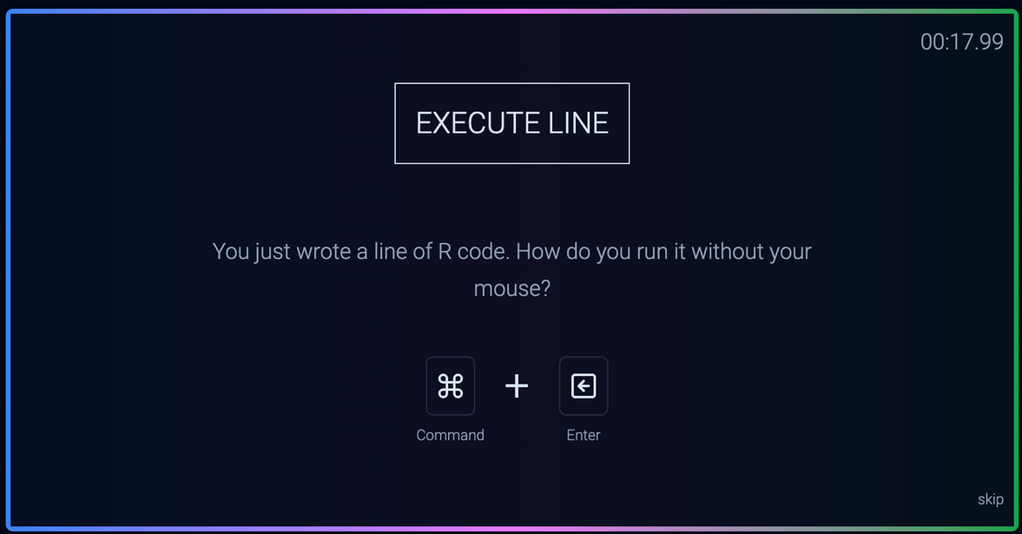

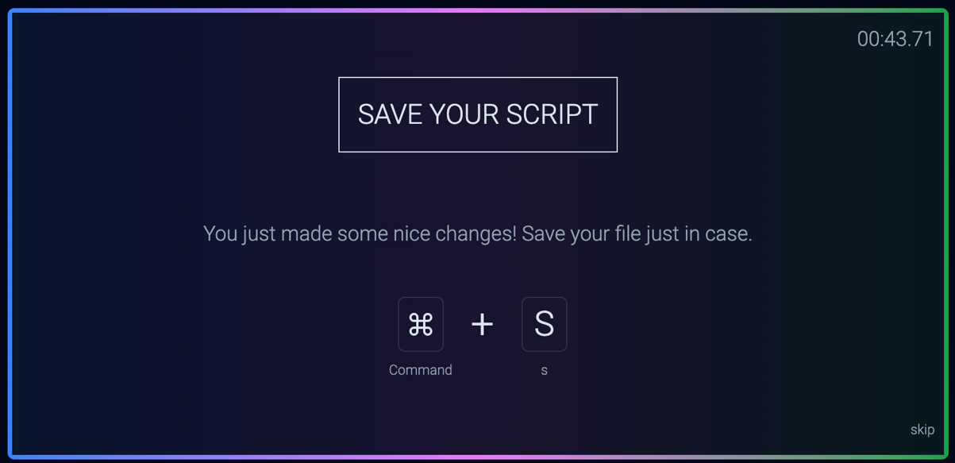

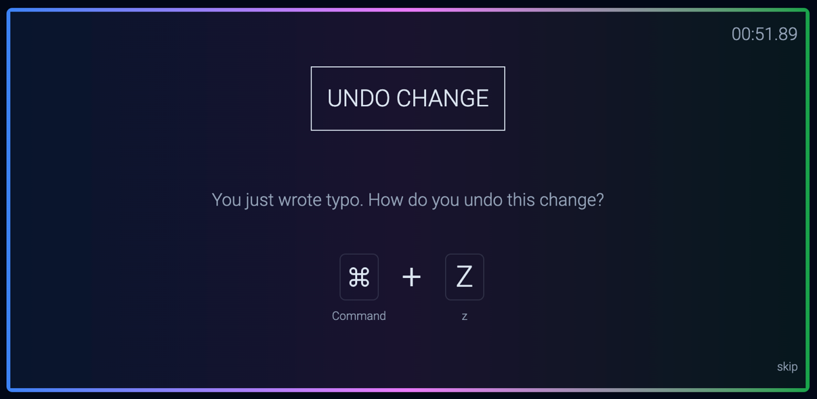

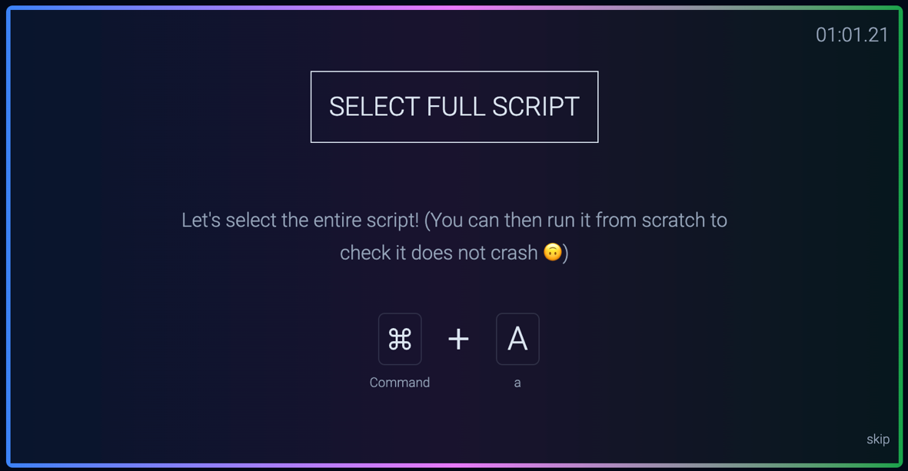

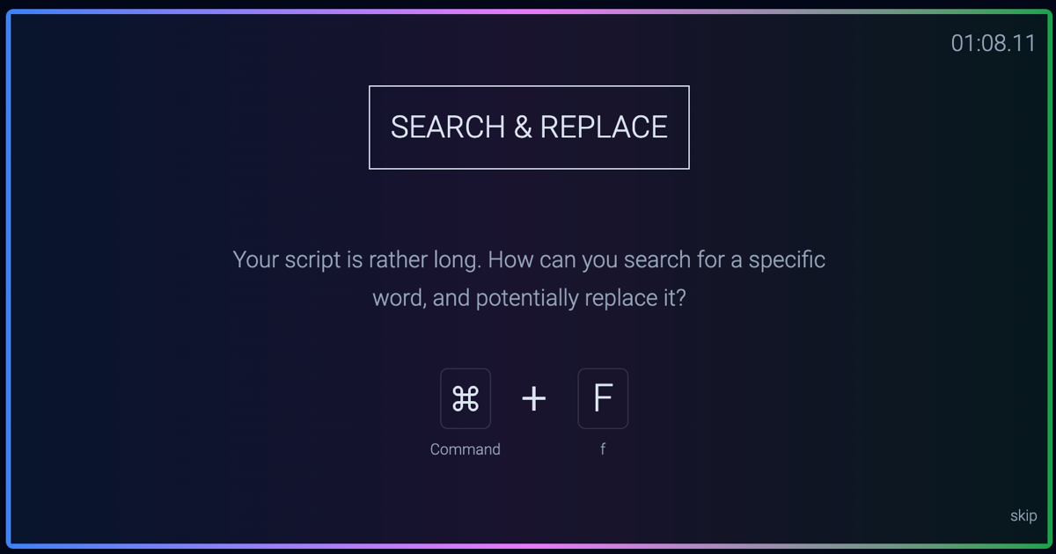

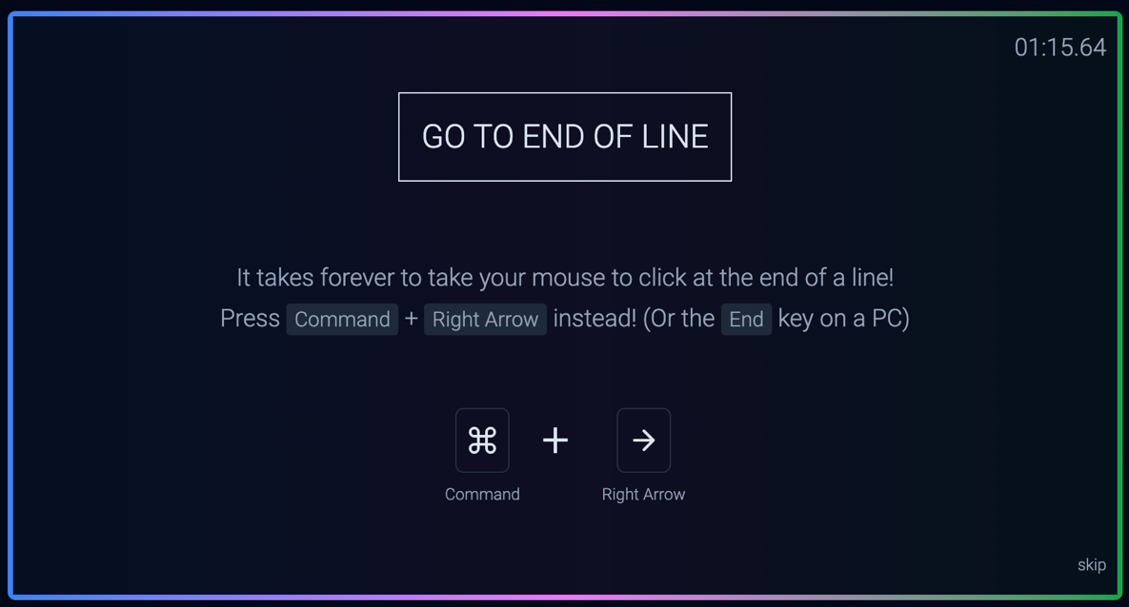

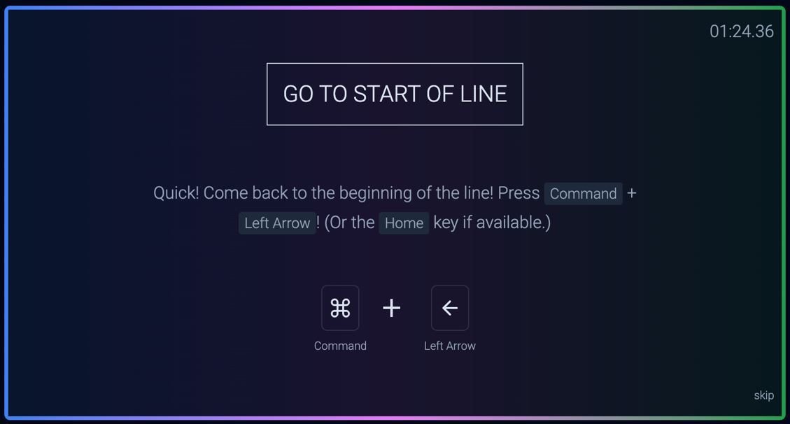

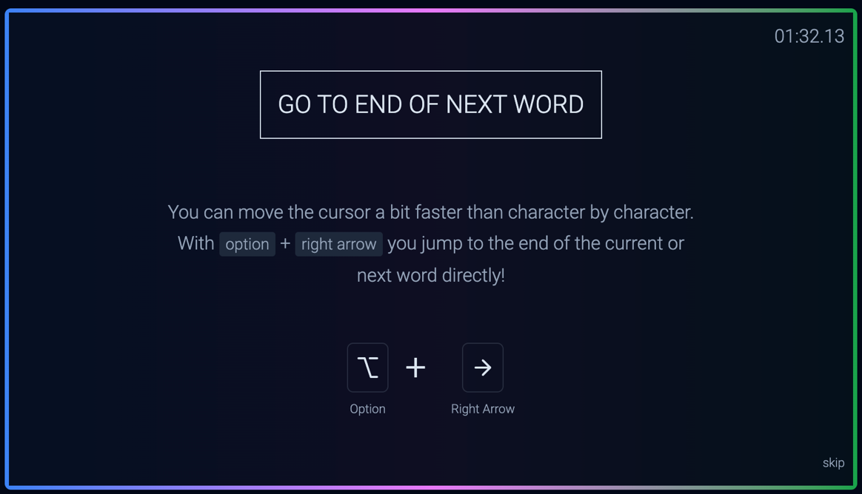

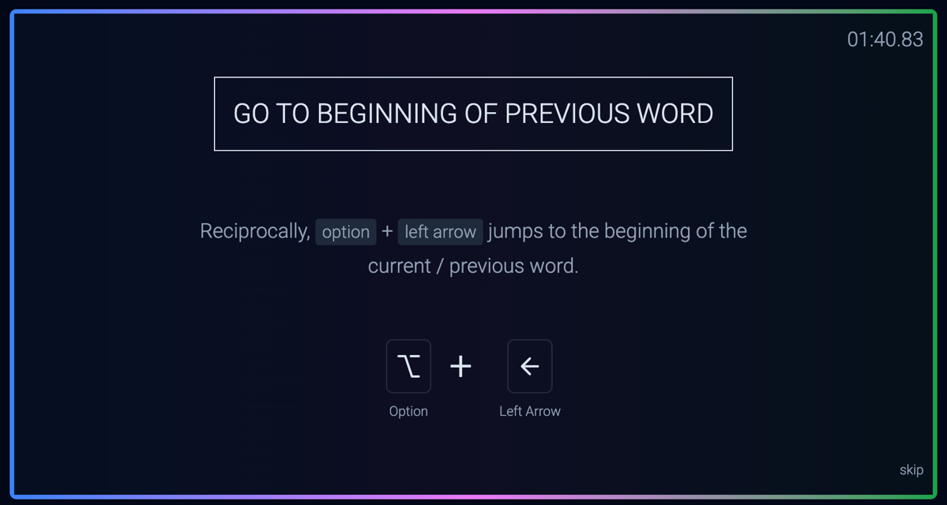

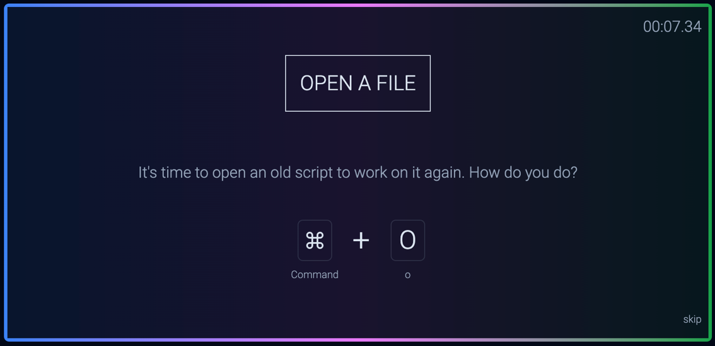

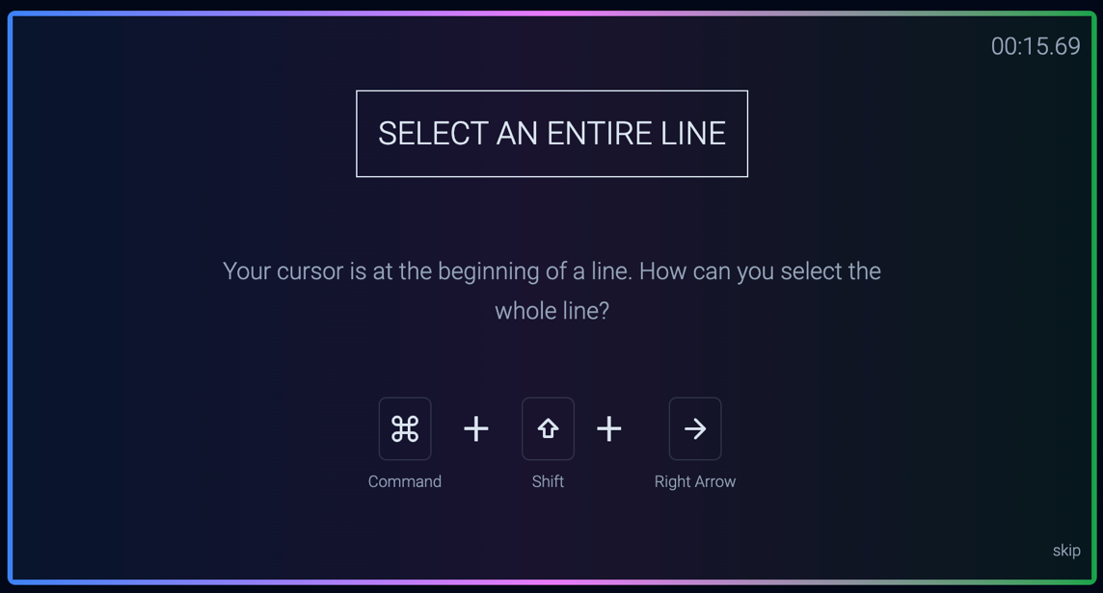

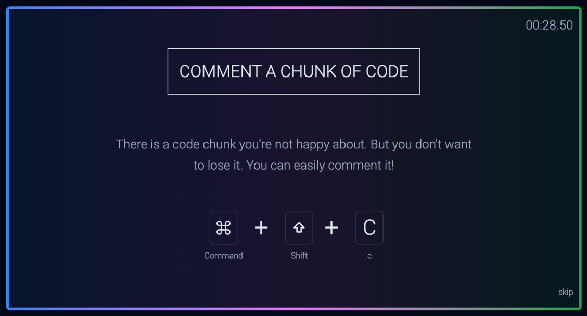

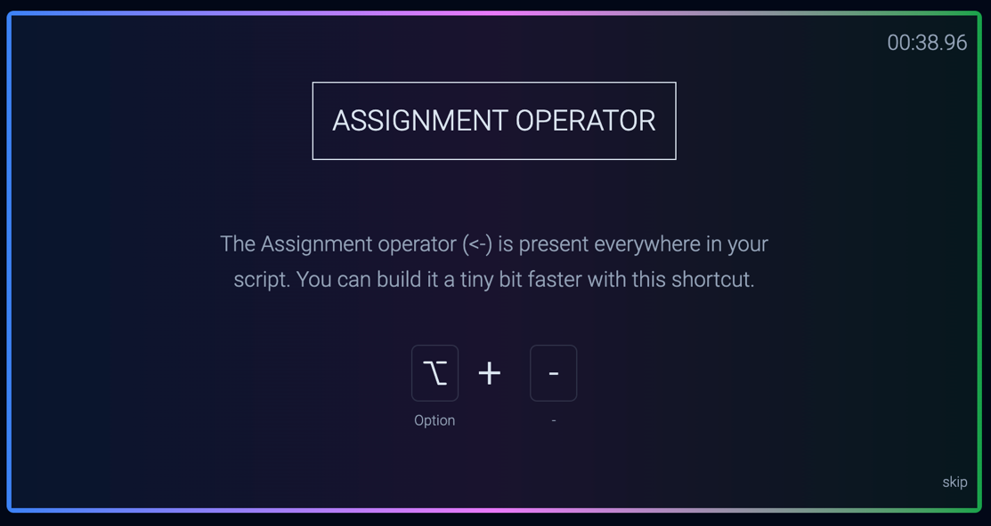

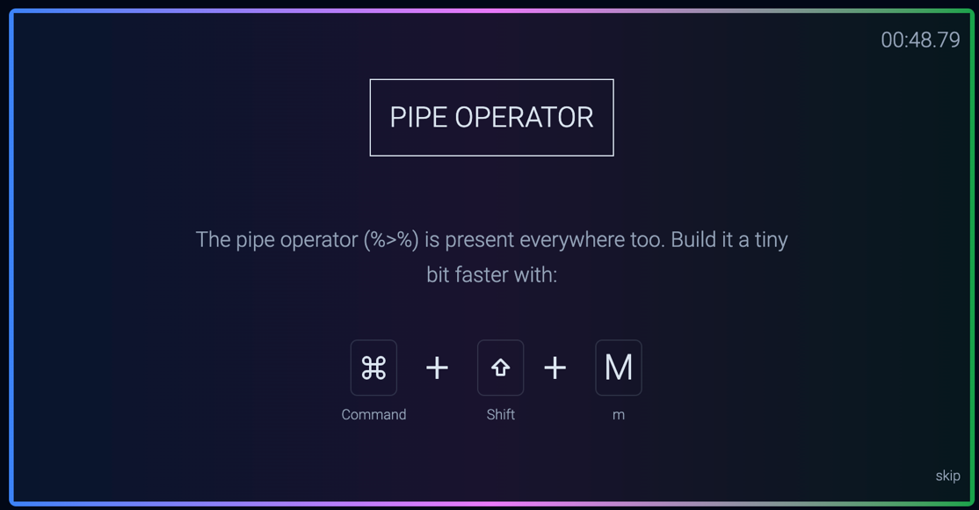

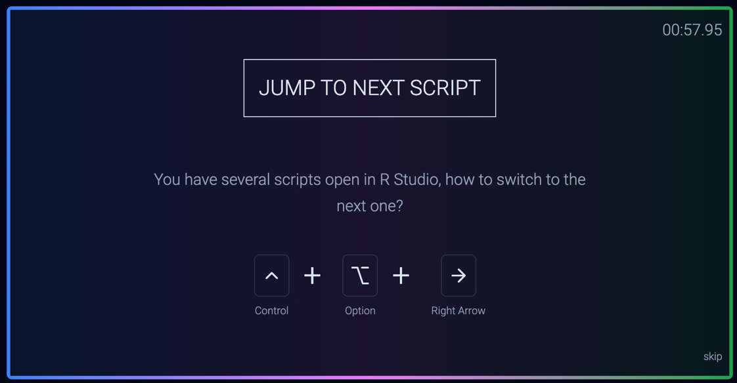

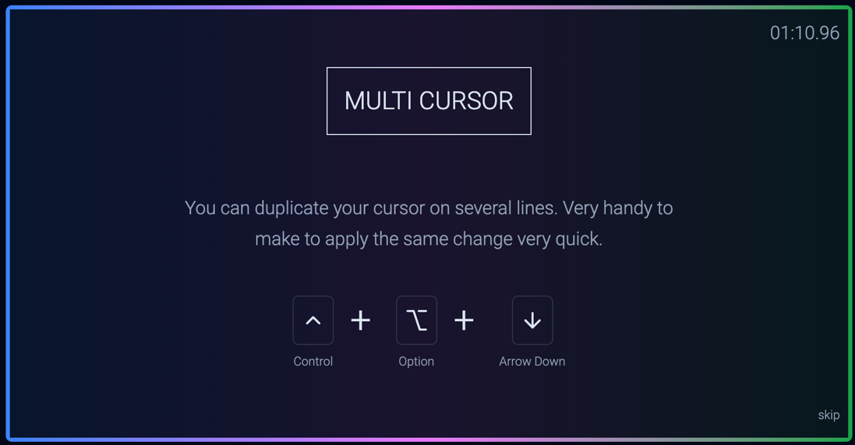

In chunk header

echo=FALSE - hides the code in a chunk from the final output

include=FALSE - omits the chunk’s output from the document

```{r, warning=FALSE, message=FALSE}

Or

```{r}

#| warning: FALSE

#| message: FALSE